SCCC Brentwood Campus News October 19, 2017

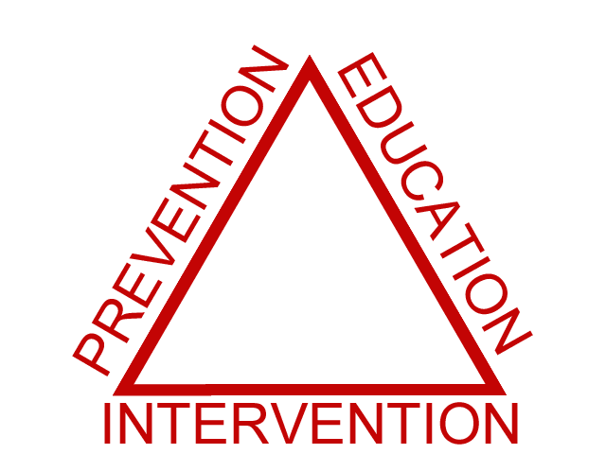
Prevention is Happening in the Chemical Dependency Counseling Program

The CDC program has been awarded a 5-year NYS OASAS – College Environmental Prevention: Using the Strategic Prevention Framework to Prevent & Reduce Underage Drinking & Drug grant.

The focus of the Prevention Grant is the prevention and reduction of underage alcohol use as well as tobacco and other drug consumption. Efforts will include reducing access and availability of substances on campus and in the surrounding community. The grant will increase efforts in the area of changing attitudes and norms that support college underage drinking and drug use including prescription drug misuse and abuse. Students, staff and faculty members will receive training to provide Screening Brief Intervention and Referral to Treatment (SBIRT) services for our students.

As a result of the grant goals and related objectives, it is expected that our community will see a decrease in alcohol and other drug-related consequences such as academic difficulties, alcohol overdoses and injuries, and assaults.

Grant efforts will utilize evidence based environmental strategies, which include:
- Preventing access or the methods in which college students procure alcohol e.g., fake identification or third party transactions
- Changing the campus community norms that promote underage drinking
- Prevention and reduction of drug use including prescription misuse
- Development of a Campus Community Coalition, who’s focus will be to create a plan to implement effective strategies to reduce availability and problems associated with college drinking, substance abuse and misuse of prescription drugs.
  - Campus members will be comprised of representative’s from varies department including Health Services, Student Service/Counseling, Public Safety, Student groups, and Faculty members.
  - Community members will be comprised of parents, teachers, law enforcement, businesses, religious leaders, health providers and other community activists who are mobilizing at the local level to make their communities safer, healthier and drug-free.

One of the first actions of the Prevention Grant is an Alcohol, Tobacco & Other Drug Survey. The survey will evaluate student’s concerns, attitudes and knowledge about drinking and drug use, their experience with individuals who have been drinking, and their own experiences with alcohol and other drugs. A random sample of SCCC students will be sent an email inviting them to participate in the survey. The survey will be conducted three times over the next five years. The results of the survey will give us a better understanding of our students substance use, guiding our prevention efforts.

A full-time prevention specialist has been hired to coordinate the grant. For more information and/or to get involved in prevention activities contact Kathleen Flynn-Bisson, CDC Prevention Program Coordinator, (631) 851-6562, flynnk@sunysuffolk.edu HSEC rm. 135

