**GOOD LUCK !**

**20 $50 Amazon Gift Cards to be given away - are you interested?**

All you have to do is respond to an email & take a quick survey.

[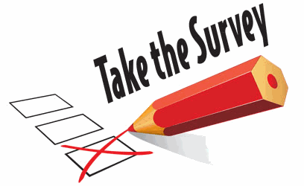](https://www.google.com/url?sa=i&rct=j&q=&esrc=s&source=images&cd=&cad=rja&uact=8&ved=0ahUKEwiCl5blnvjWAhWJhRoKHTgjAAAQjRwIBw&url=https://autismontheseas.com/foundation-programs/research-survey&psig=AOvVaw12FlkjpWC9eH50_L-uMGct&ust=1508349735875222)

All Grant-Brentwood Campus students will receive an email inviting them to participate in a brief survey. All you have to do is respond to the email and take the survey & you will be entered in the drawing to **WIN A $50 AMAZON GIFT CARD**.

The survey is part of an OASAS Prevention Grant awarded to the **CDC-Chemical Dependency Counseling Program**. The survey is looking at student’s attitudes & knowledge about drinking & other drug use, their experience with individuals who have been drinking, & their own experiences with alcohol & other drugs. The survey will take about 10 to 15 minutes.

Respond to the email that says

**“Substance Use Survey – Participate for a chance to win an Amazon Gift Card!”**

complete the survey & you will automatically be entered to win a $50 Amazon gift card – there will be 20 winners in total.

For more information about the survey or the CDC program you can contact **Kathleen Flynn-Bisson,** CDC Prevention Program Coordinator, 631-851-6443 or [flynnk@sunysuffolk.edu](mailto:flynnk@sunysuffolk.edu)